21.Write a Pandas program to swap the cases of a specified character column in a given DataFrame.

SOLUTION:

import pandas as pd

# Sample DataFrame

data = {'Name': ['Alice', 'Bob', 'Charlie', 'David'],

'City': ['New York', 'Los Angeles', 'Chicago', 'Houston']}

df = pd.DataFrame(data)

# Swap the case of the 'City' column

df['City'] = df['City'].str.swapcase()

print(df)

OUTPUT:

Name City

0 Alice nEW yORK

1 Bob lOS aNGELES

2 Charlie cHICAGO

3 David hOUSTON

1. Write a Python program to draw a line with suitable label in the x axis, y axis and a title.  
   SOLUTION:

# prompt: .Write a Python program to draw a line with suitable label in the x axis, y axis and a title.

import matplotlib.pyplot as plt

# Sample data (replace with your actual data)

x = [1, 2, 3, 4, 5]

y = [2, 4, 1, 5, 3]

# Create the plot

plt.plot(x, y)

# Add labels and title

plt.xlabel("X-axis")

plt.ylabel("Y-axis")

plt.title("Line Plot")

# Display the plot

plt.show()

OUTPUT:

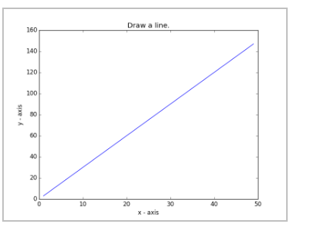

1. Write a Python program to draw a line using given axis values taken from a text file, with suitable label in the x axis, y axis and a title.  
   Test Data:  
   test.txt  
   1 2  
   2 4  
   3 1

SOLUTION:

import matplotlib.pyplot as plt

# Read data from the text file

x, y = [], []

with open('test.txt', 'r') as file:

    for line in file:

        xi, yi = map(int, line.split())

        x.append(xi)

        y.append(yi)

# Create the plot

plt.plot(x, y)

# Add labels and title

plt.xlabel("X-axis")

plt.ylabel("Y-axis")

plt.title("Line Plot from test.txt")

# Display the plot

plt.show()

OUTPUT

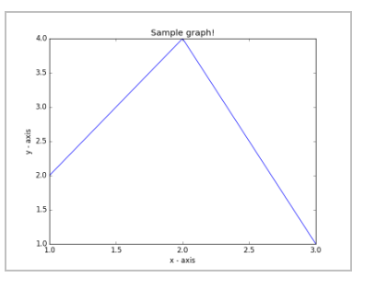

1. Write a Python program to draw line charts of the financial data of Alphabet Inc. between October 3, 2016 to October 7, 2016.  
   Sample Financial data (fdata.csv):  
   Date,Open,High,Low,Close  
   10-03-16,774.25,776.065002,769.5,772.559998  
   10-04-16,776.030029,778.710022,772.890015,776.429993  
   10-05-16,779.309998,782.070007,775.650024,776.469971  
   10-06-16,779,780.47998,775.539978,776.859985  
   10-07-16,779.659973,779.659973,770.75,775.080017

SOLUTION:

import pandas as pd

import matplotlib.pyplot as plt

]# Load the data from the CSV file

df = pd.read_csv('fdata.csv')

# Convert the Date column to datetime format

df['Date'] = pd.to_datetime(df['Date'], format='%m-%d-%y')

# Plot the line charts for the financial data

plt.figure(figsize=(10,6))

# Plot Open, High, Low, and Close prices over the dates

plt.plot(df['Date'], df['Open'], label='Open', marker='o')

plt.plot(df['Date'], df['High'], label='High', marker='o')

plt.plot(df['Date'], df['Low'], label='Low', marker='o')

plt.plot(df['Date'], df['Close'], label='Close', marker='o')

# Labeling the axes and title

plt.xlabel('Date')

plt.ylabel('Price (USD)')

plt.title('Financial Data of Alphabet Inc. (Oct 3, 2016 to Oct 7, 2016)')

# Show grid and legend

plt.grid(True)

plt.legend()

# Display the plot

plt.xticks(rotation=45)

plt.tight_layout()

plt.show()

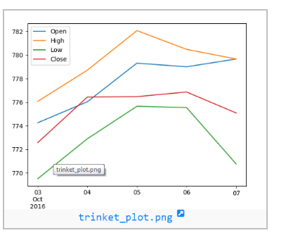

1. Write a Python program to plot two or more lines with legends, different widths and colors.

SOLUTION:

import matplotlib.pyplot as plt

# Data for the plot

x = [1, 2, 3, 4, 5]

y1 = [1, 4, 9, 16, 25]

y2 = [1, 2, 3, 4, 5]

# Create a plot

plt.plot(x, y1, label='y = x^2', color='blue', linewidth=2) # First line with blue color and width 2

plt.plot(x, y2, label='y = x', color='red', linewidth=3) # Second line with red color and width 3

# Add labels and title

plt.xlabel('X axis')

plt.ylabel('Y axis')

plt.title('Multiple Lines with Legends, Different Widths, and Colors')

# Display legend

plt.legend()

# Show the plot

plt.show()

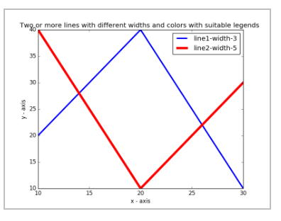

1. Write a Python program to create multiple plots.

Solution:

# prompt: Write a Python program to create multiple empty plots.

import matplotlib.pyplot as plt

# Create multiple empty subplots

fig, axes = plt.subplots(2, 2, figsize=(8, 6))  # 2 rows, 2 columns

# Customize each subplot (optional)

axes[0, 0].set_title("Plot 1")

axes[0, 1].set_title("Plot 2")

axes[1, 0].set_title("Plot 3")

axes[1, 1].set_title("Plot 4")

# Display the plot with empty subplots

plt.tight_layout()  # Adjust spacing between subplots

plt.show()



1. Write a Python programming to display a bar chart of the popularity of programming Languages.  
   Sample data:  
   Programming languages: Java, Python, PHP, JavaScript, C#, C++  
   Popularity: 22.2, 17.6, 8.8, 8, 7.7, 6.7

SOLUTION:

import matplotlib.pyplot as plt

# Data

languages = ['Java', 'Python', 'PHP', 'JavaScript', 'C#', 'C++']

popularity = [22.2, 17.6, 8.8, 8, 7.7, 6.7]

# Create the bar chart

plt.bar(languages, popularity, color='skyblue')

# Add labels and title

plt.xlabel('Programming Languages')

plt.ylabel('Popularity (%)')

plt.title('Popularity of Programming Languages')

# Display the plot

plt.show()

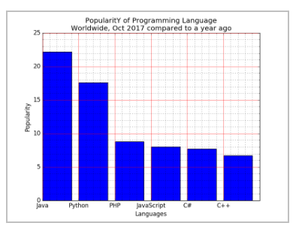

27.rite a Python programming to display a horizontal bar chart of the popularity of programming Languages.  
Sample data:  
Programming languages: Java, Python, PHP, JavaScript, C#, C++  
Popularity: 22.2, 17.6, 8.8, 8, 7.7, 6.7

SOLUTION

import matplotlib.pyplot as plt

# Data

languages = ['Java', 'Python', 'PHP', 'JavaScript', 'C#', 'C++']

popularity = [22.2, 17.6, 8.8, 8, 7.7, 6.7]

# Create the horizontal bar chart

plt.barh(languages, popularity, color='lightgreen')

# Add labels and title

plt.xlabel('Popularity (%)')

plt.ylabel('Programming Languages')

plt.title('Popularity of Programming Languages (Horizontal Bar Chart)')

# Display the plot

plt.show()

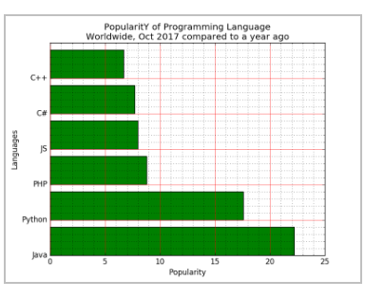

1. Write a Python programming to display a bar chart of the popularity of programming Languages. Use different color for each bar.  
   Sample data:  
   Programming languages: Java, Python, PHP, JavaScript, C#, C++  
   Popularity: 22.2, 17.6, 8.8, 8, 7.7, 6.7

SOLUTION

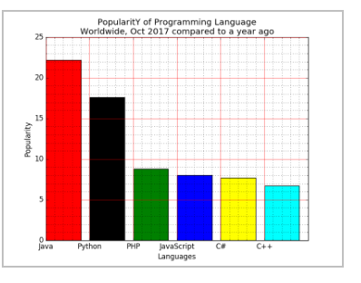

1. Write a Python program to create bar plot of scores by group and gender. Use multiple X values on the same chart for men and women.  
     
   Sample Data:  
   Means (men) = (22, 30, 35, 35, 26)  
   Means (women) = (25, 32, 30, 35, 29

SOLUTION:

import matplotlib.pyplot as plt

import numpy as np

# Data

groups = ['Group 1', 'Group 2', 'Group 3', 'Group 4', 'Group 5']

means_men = [22, 30, 35, 35, 26]

means_women = [25, 32, 30, 35, 29]

# X locations for groups

x = np.arange(len(groups))

# Width of the bars

width = 0.35

# Create the bar plot

fig, ax = plt.subplots()

bar1 = ax.bar(x - width/2, means_men, width, label='Men', color='skyblue')

bar2 = ax.bar(x + width/2, means_women, width, label='Women', color='salmon')

# Add labels and title

ax.set_xlabel('Groups')

ax.set_ylabel('Scores')

ax.set_title('Scores by Group and Gender')

ax.set_xticks(x)

ax.set_xticklabels(groups)

ax.legend()

# Display the plot

plt.show()

OUTPUT:

